THE UNIVERSITY OF BURDWAN
DEPARTMENT OF CONTROLLER OF EXAMINATIONS

No. CE – Sectt / UG Special Exam 2020 / 106 Dated : 16.10.2020

NOTIFICATION
It is notified for information of all concerned that the candidates who applied to appear at special examination of UG CBCS Semester-VI Examinations, 2020 and UG Part-III Examinations, 2020 by filling-up their examination forms on 08.10.2020 and 09.10.2020 and appeared at the paper/courses on and from 10.10.2020 onwards following the existing schedule [vide our earlier notification no. C/Prog/UGSem-VI(Hons&Gen)under CBCS2020/145/Con, dated 24.09.2020 and vide notification no. C/Prog/UG Part-III(Hons& Gen)’20/146/Con, dated 24.09.2020] of respective examinations (Papers/Courses) will be considered as valid.
However, these candidates will now be permitted to appear at the at the special examination (UG CBCS Sem VI / UG Part III Examination 2020) on the paper(s) / course(s) which were held during the period from 01.10.2020 to 09.10.2020.
Accordingly, the programme of the aforesaid special examination will be published shortly.
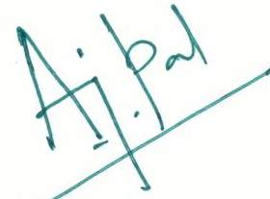

A. J. Pal
Controller of Examinations

